TRYHACKME LAB WRITEUP 02 / 04

Intro to Logs
  - Training-room summary and evidence-aware reflection

Training reference
https://tryhackme.com/room/introtologs

Learning objectives
- Describe why logs support detection, investigation and accountability.
- Distinguish log sources and data fields.
- Understand aggregation, retention and consistency across time zones.

Concepts reviewed
Log entries are time-ordered evidence: source, timestamp, event type and context determine whether an event is important.

Approach and SOC interpretation
- Identify which log or packet field directly supports a claim.
- Filter by event time and asset before drawing conclusions.
- Explain to a SOC analyst why the result could matter and how it may be validated.

Evidence and completion status
Learner reported completing this room; the supplied ZIP contains the room screenshot. Screenshot evidence is attached below.
The provided room screenshot supports progress, not individual task steps; this writeup does not invent task answers.
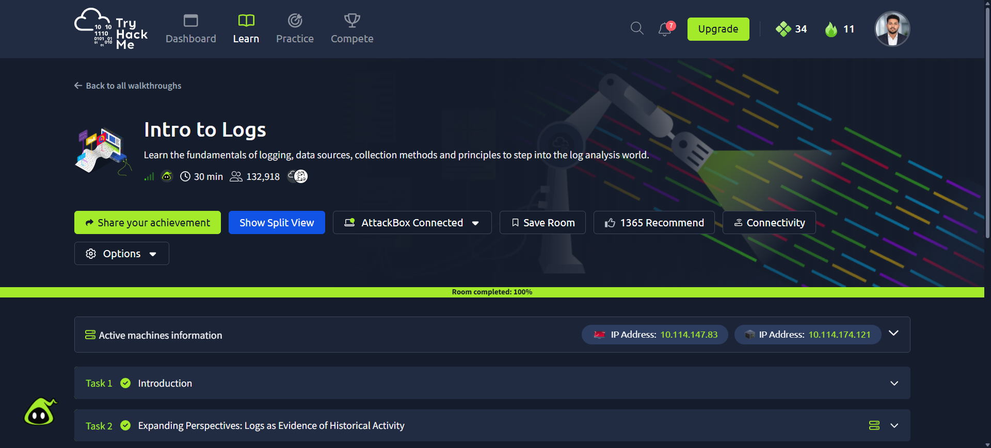
Evidence: source screenshot provided for Intro to Logs

Reflection / relation to the lab
This room connects to the Windows Sysmon, Linux auditd and Snort exercises documented in the Week 3 practical report. Specific room questions, answers and typed commands are intentionally not claimed without source evidence.

